GANPAT UNIVERSITY
U.V.PATEL COLLEGE OF ENGINEERING & TECHNOLOGY
Department of Computer Science and Engineering
B.Tech 1ST Semester Subject –ESFP
First Name:Kushal Dhayal Stream :CSE(Bid Data & Analysis)

Assignment-1 DATE-27/8/2014
Q-1. Write a program to print ASCII values of all backslash characters and white space on screen in following format :
The ASCII value of ‘\t’ is : 9
(Hint : you can verify your ASCII values with the help of a table for ASCII values from text book)
Ans->

#include<stdio.h>
#include<conio.h>
void main()
{
char a;
clrscr();
a='\a';
printf("\nthe ascii value of'\\a' is:%d",a);
a='\b';
printf("\nthe ascii value of '\\b' is:%d",a);
a='\f';
printf("\nthe ascii value of '\\f' is:%d",a);
a='\n';
printf("\nthe ascii value of '\\n' is:%d",a);
a='\r';
printf("\nthe ascii value of '\\r' is:%d",a);
a='\t';
printf("\nthe ascii value of '\\t' is:%d",a);
a='\v';
printf("\nthe ascii value of '\\v' is:%d",a);
a='\?';
printf("\nthe ascii value of '\\?' is:%d",a);
a='\\';
printf("\nthe ascii value of '\\\' is:%d",a);
getch();
}

OUTPUT:
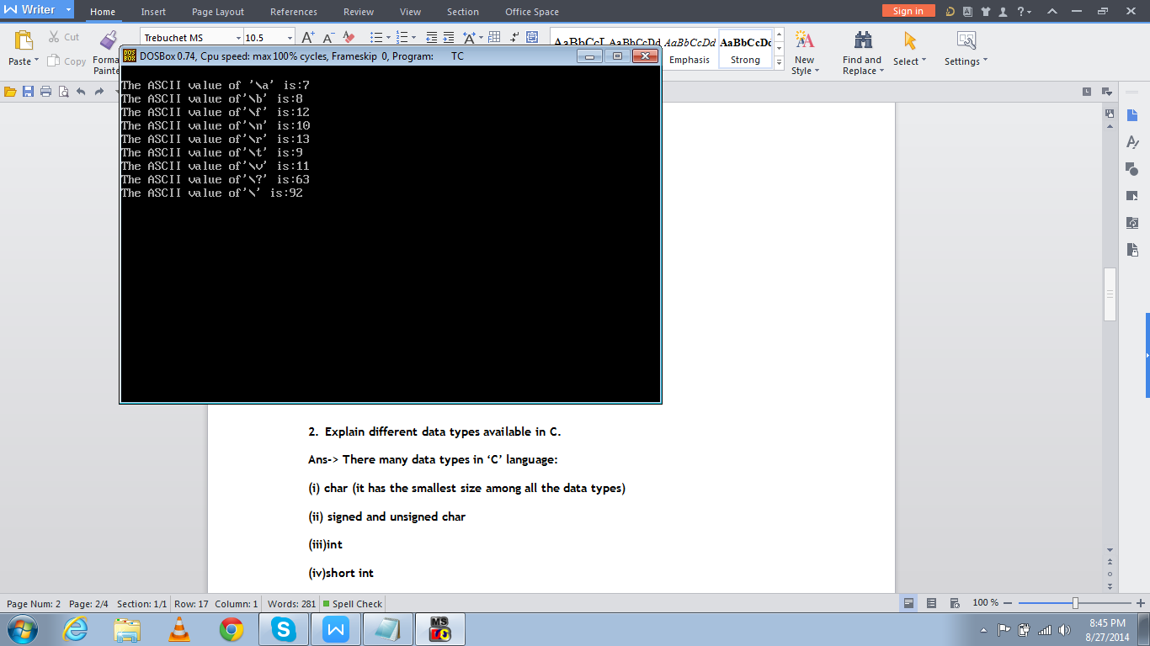

- Explain different data types available in C.
Ans-> There many data types in ‘C’ language:
(i) char (it has the smallest size among all the data types)
(ii) signed and unsigned char
(iii)int
(iv)short int
(v)double
(vi)float
- Explain about C Tokens in brief.
Ans-> In a C source program, the basic element recognized by the compiler is the "token." A token is source-program text that the compiler does not break down into component elements.

Different types of tokens:

keyword
identifier
constant
string-literal
operator
Punctuator

- Explain about backslash characters in C.
Ans->A character that follows a backslash character (\) in a character must be one of the following characters:
', ", \, 0, a, b, f, n, r, t, u, U, x, v.

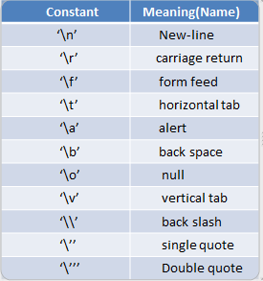

******THANK YOU******

